Exercise 4

To fulfill Exercise 4, we chose the domain hotel booking.

We wrote two wrappers: extracting data from **expedia.de** using ***import.io*** and extracting data from **de.hotels.com** using ***Mozenda***.

First we show the process of extracting data:

**Mozenda Agent**

Page: de.hotels.com

Input:

* Place
* Checkin
* Checkout

anzeige.htm

Output: mozenda.xml

Output: tmp.xml

**Import.io Extractor**

Page: expedia.de

Input:

* Place
* Checkin
* Checkout

**Integrate.py**

Query import.io Extractor

Read tmp.xml

* Combine and normalize

Fig 1: Process of wrapping data from two sources. First, the Mozenda Agent runs manually (because the REST API is not available). Then data are exported as XML and stored in mozenda.xml. The python script integrate.py triggers the import.io extractor with provided user input. So links to detail pages are extracted using one import.io extractor, and these links are used with a second extractor to extract detail hotel information as XML. Data from mozenda.xml is read, and data from both sources are normalized and stored in tmp.xml. anzeige.htm reads the file tmp.xml and displays output in a table. If available, images are displayed, if not, just a text is displayed. The color code corresponds to the wrapper source, after moving the mouse over an hotel thumbnail, data extracted from the detail links is displayed.

The output (anzeige.htm) looks as follows:

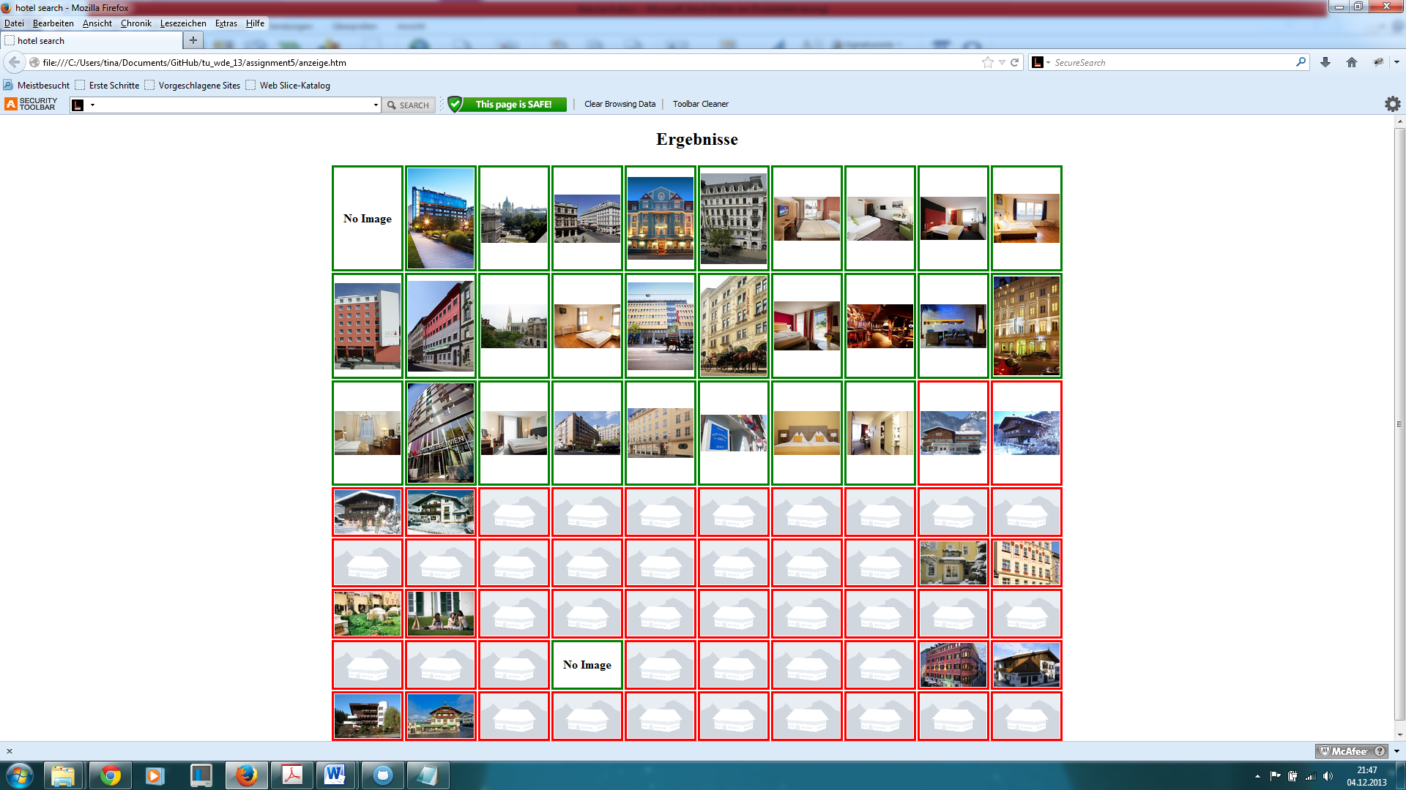

Fig 1: Hotel thumbnails are displayed in a table (if available, otherwise just a text is displayed). A green border corresponds to source mozenda (de.hotels.com), a red border to source import.io (expedia.de).

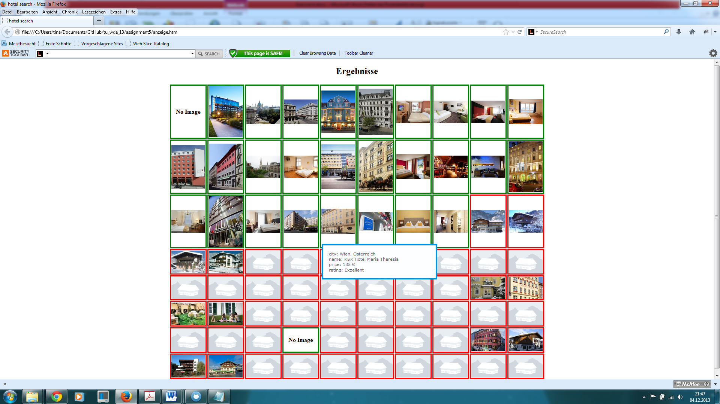

Fig 2: When moving over a hotel thumbnail, information extracted from the detail pages is provided.

Now we provide some information on the used wrappers.

**Import.io** is a completely web-based builder, very fast to learn, but somehow limited. Pagination should work, you can also train it, but after building the wrapper, it is not carried out. After creating the extractor, we query it using a provided python modul.

Here are screenshots from the work with **import.io**:

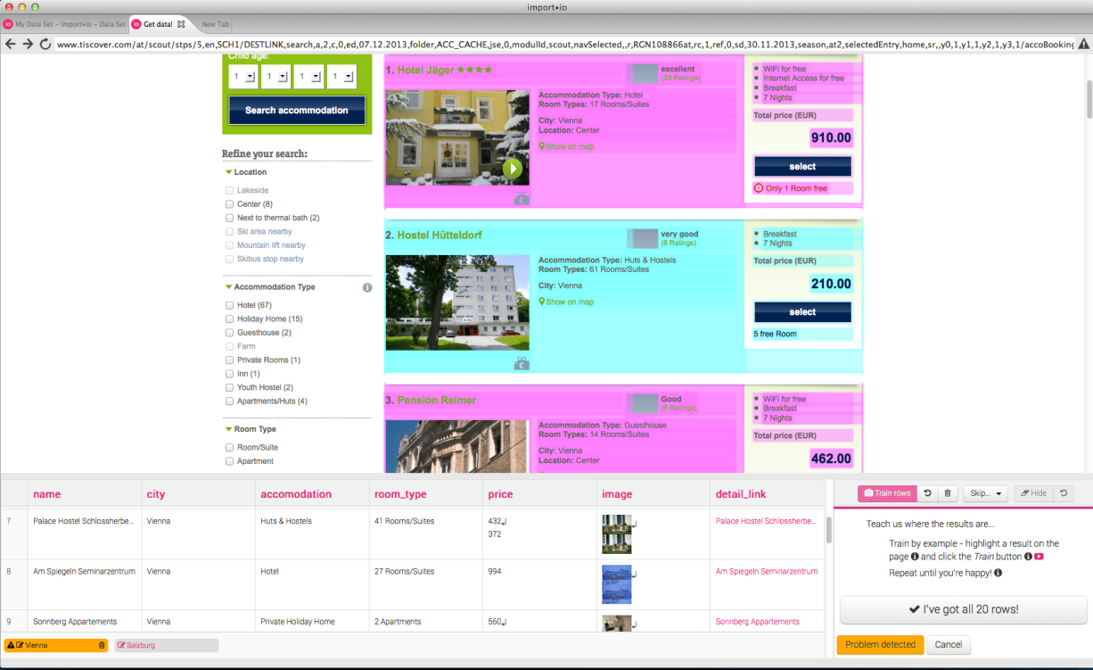

Fig. 4: You always have to choose two to five example objects, so import.io can detect a list of other objects to extract (training the extractor).

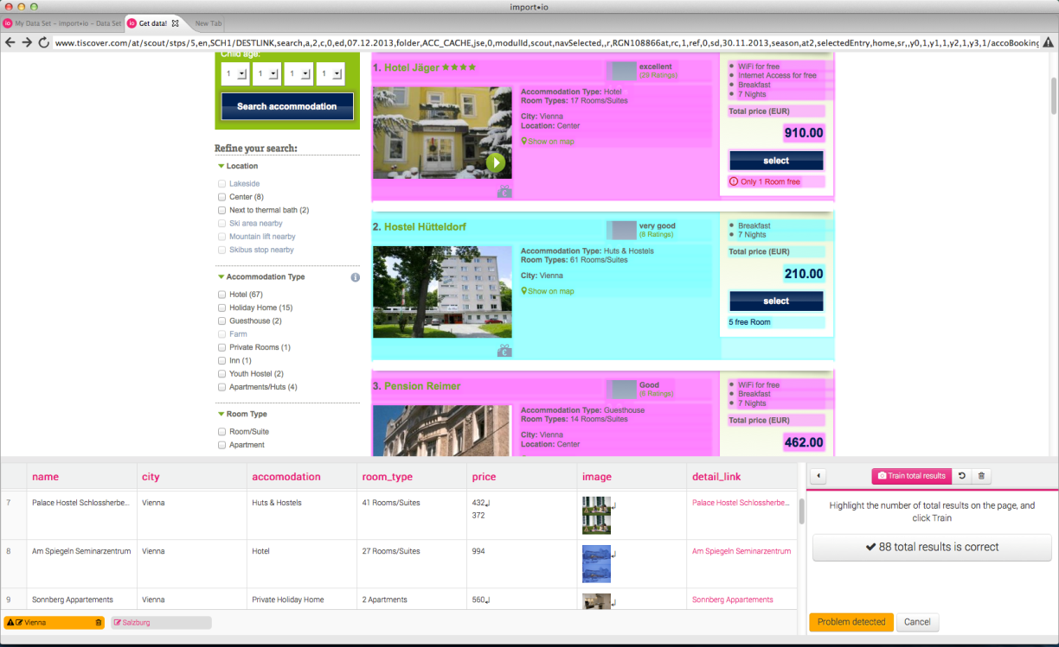

Fig 5: All the captured content is displayed at the bottom for control purpose.

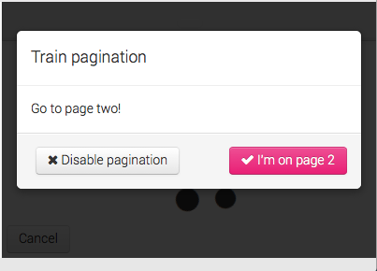

Fig 6: Import.io should be able to train pagination (following next links), but in fact it doesn’t work.

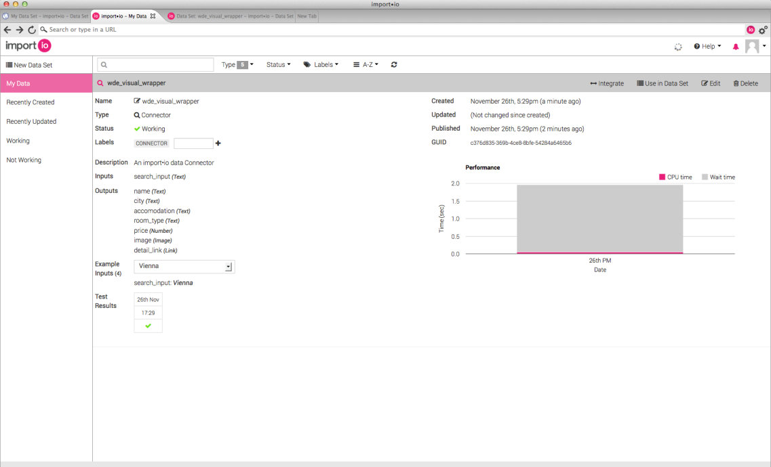

Fig 7: After creating the wrapper, it is stored online and can be queried.

**Mozenda** is a very easy and intuitive tool for creating web extractors. You have to download a software called AgentBuilder, to build and test your agents locally. After creating an extractor, you upload it tot he mozenda server, where it can be run ( you can define schedules and query data using the REST API, but it is not available in the trial version). The agent itself is clearly structured, the actions are shown on the left bottom, jumps to other steps (linke pagination or following detail links) are illustrated by numbers, and details about every action is displayed in the left upper side.

Here are screenshots from working with **Mozenda:**

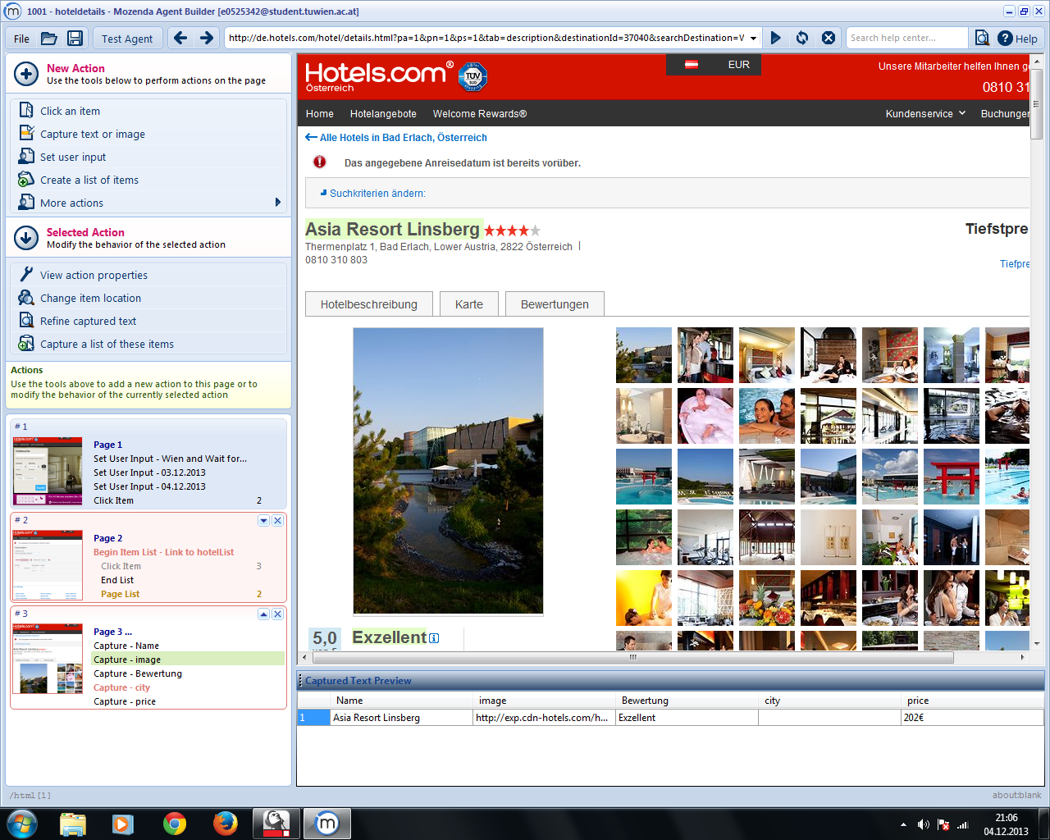

Fig 8: Mozenda is very clearly structured and intuitive; Results are displayed immediately

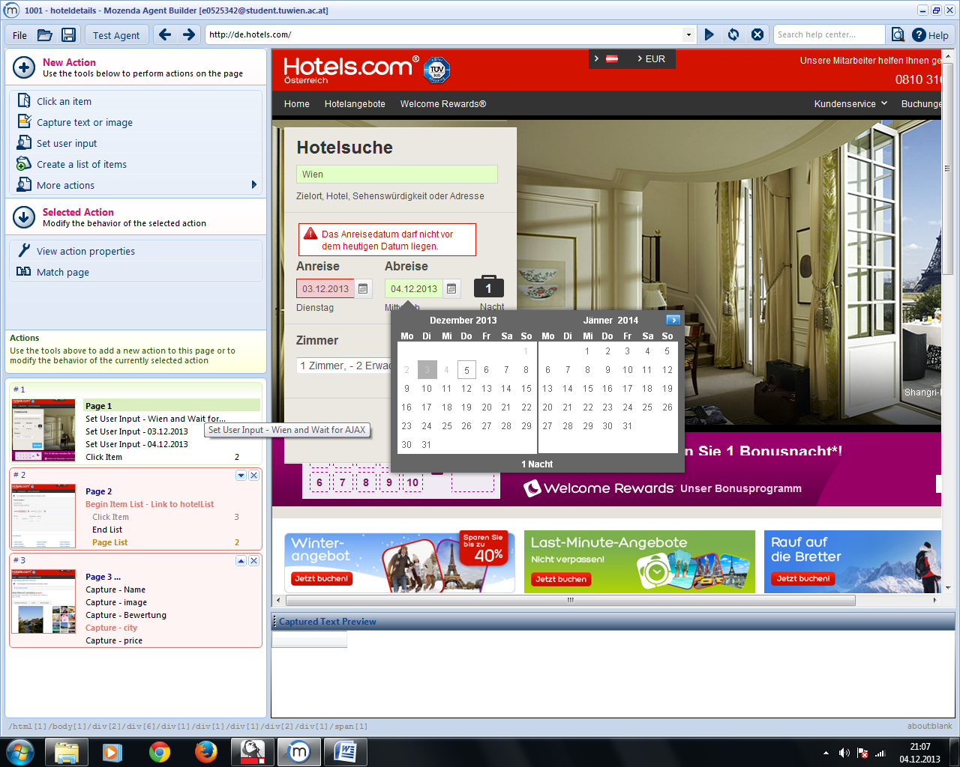

Fig 9: on the left side, you can see the sequence of actions carried out, also the jumps to different steps (like following next or detail links)

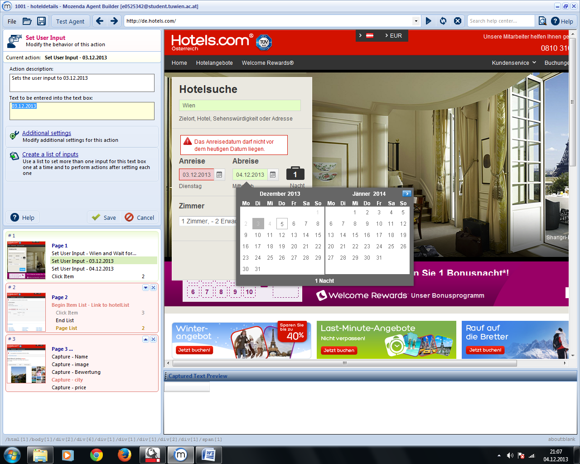

Fig 10: On the left upper site you can define user inputs for input variables

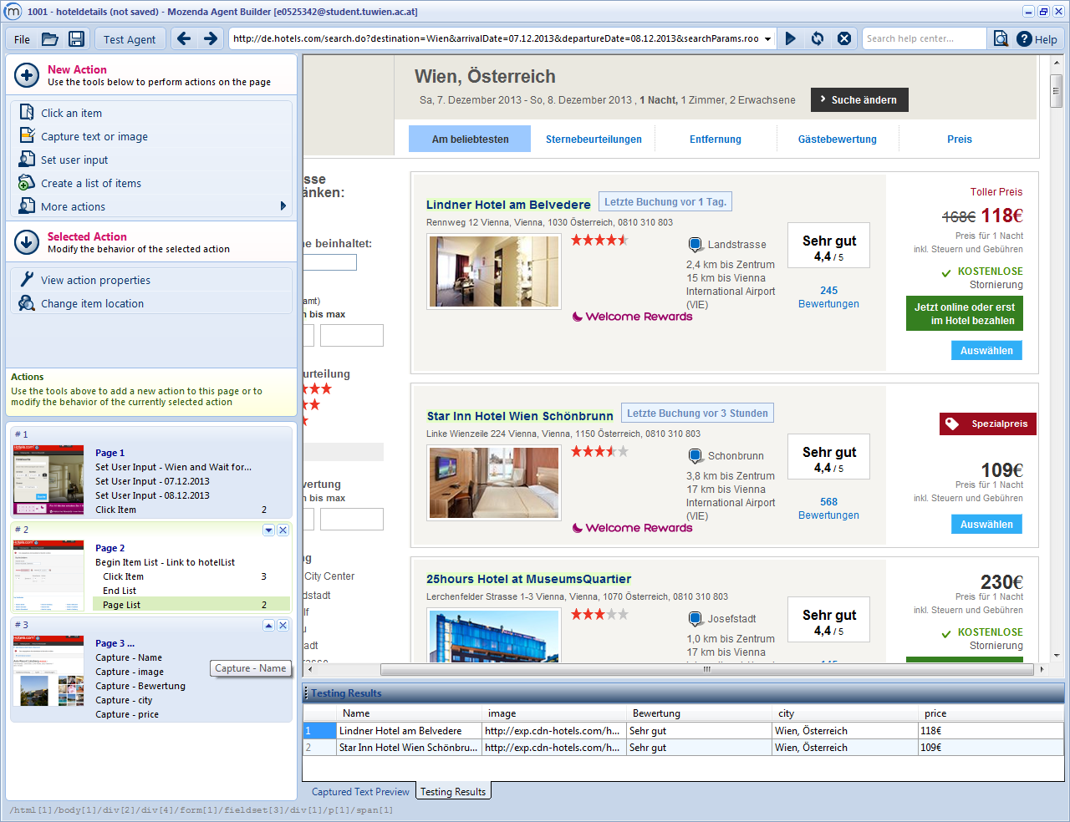

Fig 11: After building the agent, you can test it locally.Results are displayed at the bottom oft he software.

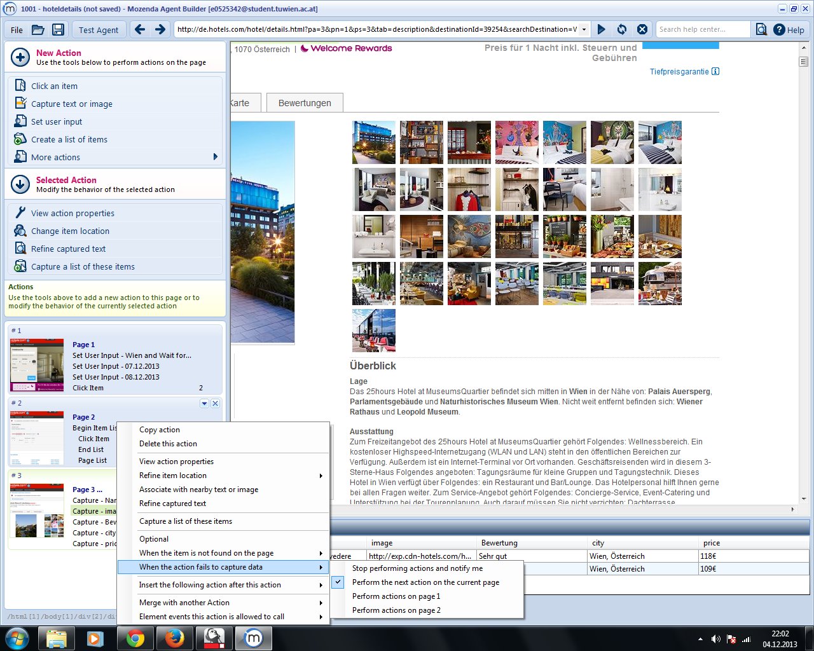

Fig 12. If condition: if action fails to capture an image from the detail link, the agent continues with performing the next action on the current page.

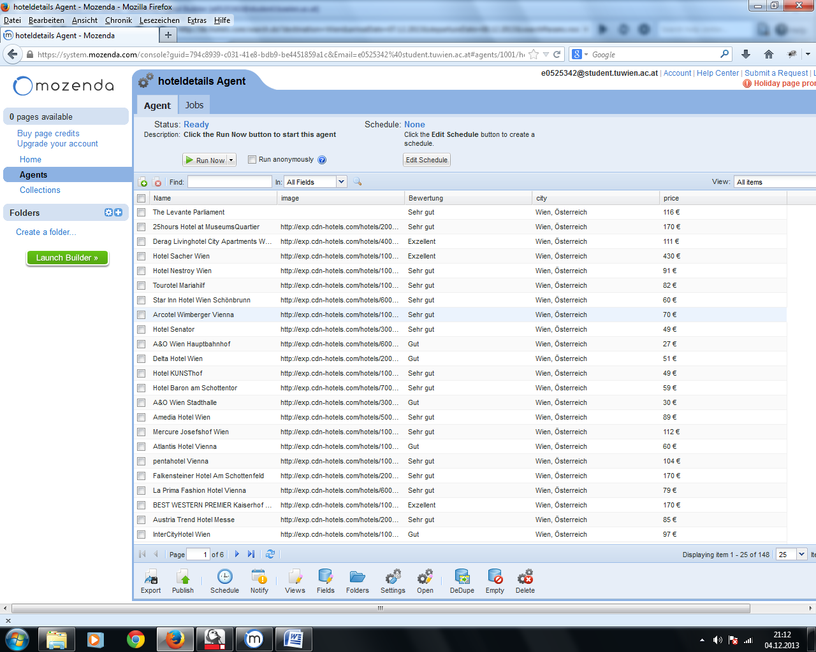

Fig 12: the Mozenda Web Console controls Agents (run, schedule) and Collections (filled by the agent)

Now we answer **additional questions.** In general, both wrappers were easy to build and quite intuitive to use. When using import.io, we had to extract detail information by using a second extractor and querying the data using the python script. On the other hand, we couldn’t query mozenda data using the REST API directly, because this is not imported for trial accounts, so weh ad to do the extraction and export manually.

**\* Document Model (DOM, Text, anything in addition to these)**

**Mozenda:** You can activate the feature, that DOM is visible in a control window at the bottom of the agent. If you click on an object, the specific DOM-entry is highlighted. But i didn’t need to know about the DOM tree in this exercise.

**\* Form Filling and Macro Recording**

**Import.io:** Quite natural I think. You navigate to the connector and can then start to record

the form filling. Having seen the Lixto Visual Developer this is very restricted

and there not much to configure.

**Mozenda:** Very easy and intuitive, took about 15 minutes to set up the whole wrapper.

**\* Transform original tree structure**

**Mozenda:** feature not needed, most of the DOM functionality is hidden from the user.

**\* Natural Language Processing Support**

**Mozenda:** Using regular expressions is supported

**\* Heuristics and Rule Generation**

**Import.io:** Sometimes the recognistion of some rules does not work very well with only a few examples. It sometimes takes put to 5 examples until the recognition of the attribute is learned.

But as far as I have worked with import.io it is very robust after it is correct.

**Mozenda:** Recognition of rules is very simple and robust. Works after choosing two examples. If a rule cannot be applied (because website changes for example),a warning is displayed.

**\* Image Recognition**

**Import.io:** Images are handled quite nice. When selecting them as a attribute of the output they

are displayed directly.

**Mozenda:** also very nice, images are displayed directly when selected as output (Testing results), they can also be downloaded.

**\* Scripting**

**Import.io:** While the rule learning is in progress there is not many parameters you can tweak.

But when the rules are completed you can access a very rich API in alot of different

languages to aquire the data.

**Mozenda:** no chance to learn the API calls since it cannot be used by a free account. Seems tob e very powerful, agents can be steered and collections can be queried using constructed links.

**\* Ajax Support and DOM Freezing, DOM Event Support**

**Import.io:** At first it always tries not to use the javascript engine. There are alot of dialogs

asking you "Does the site look as expected?". If not it is reloaded with javascript enabled.

This I think is quite good idea in terms of resources.

**Mozenda:** Agent waits for ajax-requests after loading content. Seems as if just a fixed time is waited, no matter how long the ajax- call needs to load data.

**\* Input and Output Formats**

**Import.io:** Rich set of outputs. The wrapped data can be downloaded as EXCEL,HTML,JSON or CSV and by exposing a REST API those can be processed by any programming language.

**Mozenda:** input parameters: text; output format: CSV, TSV and XML

**\* Control Browser Settings like User Agent**

**Mozenda:** Agents can be started, paused, restarted; time schedules can be defined

**\* Parameterization**

**Import.io:** Can be specified when the is fetched from the REST API. This is quite conveinient.

**Mozenda:** can be specified when using the API (not working for free account)

**\* Iteration, Conditions, Loops**

**Mozenda:** all features included but hidden from the user (like pagination, if conditions)

**\* Robustness and Adaptation**

**Mozenda:** very robuts, easy to adapt

**\* Automated Steps, Machine Learning (from multiple examples)**

**Mozenda:** very intuitive, little steps and examples needed

**\* Storing screenshots / html source to file system**

**Mozenda:** capturing a screenshot is possible, but i couldn’t find html source to file system functionality

**Import.io:** I don't think this is implemented in import.io.

**\* Performance and Scalability**

**Import.io:** Decent. Compared to open dapper it is a little faster.

**Mozenda:** quite good, but WebL was faster

**\* Ease of Use**

**Mozenda:** very easy and intuitive

**\* Proxy Variations**

**Mozenda:** couldn’t find this feature

**\* Captcha Support**

**Import.io:** I don't think there is captcha support.

**Mozenda:** i couldn’t find this functionality

**\* Execution Environment**

**Mozenda:** agent builder is the local software for testing the agent, but to extract data the agent is executed on the mozenda server